The National Education policy

The National Education Policy (NEP policy) aspires to develop an education system that directly contributes to the country’s transformation by delivering high-quality education to all citizens and developing India into a global knowledge super-power

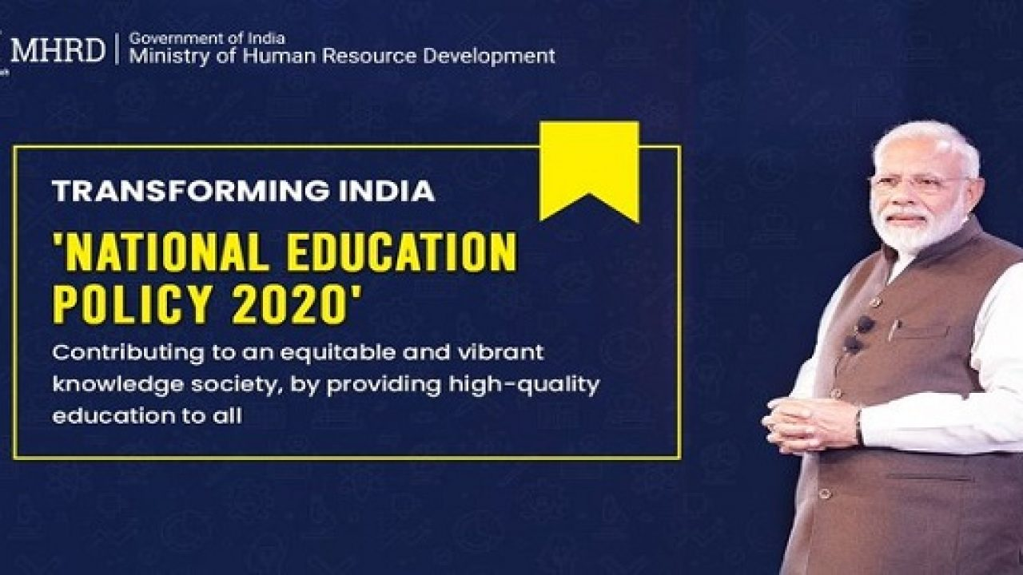

The basic aim and the objective of NEP policy 2020 are to make education universally accessible from primary to secondary level by the year 2030. It helps in building a relationship between the learner and society at large. The benefits of the policy is that the students will be provided with proper education so that they have improves their ability to read and write. Students will be

provided with proper education so that they have improves their ability to read and write. The students will be proven foundation literacy and numeracy. Also, the teachers will be appointed in the areas which are disadvantaged as compared to the basic areas of the country which are developing

As of the NEP has a compulsory schooling from the age of 6 to 14 years to 3 to 18 years. The Nep includes three years of previously unrecognized pre-schooling for children aged 3 to 6 years in the school curriculum.

The old education of India had a 10+2 schooling framework which will be replaced by a 5+3+3+4 curricular structure which is that the students will spend 5 years in the foundational stage, following 3 years under the preparatory stage, 3 years of learning in the middle stage and final 4 years in the secondary stage

In the Foundation Phase, the assessment of learning (both formal and informal) includes these forms of assessment- observation by the teacher- oral discussion- practical demonstrations, and written recording the foundation phase aims to realize the highest quality education for all the children, consistent with realizing an equitable, inclusive and plural society as envisaged by the constitution of India

The preparatory stage under the National Education policy will cover school education from class 3 to 5 with a focus on experimental learning

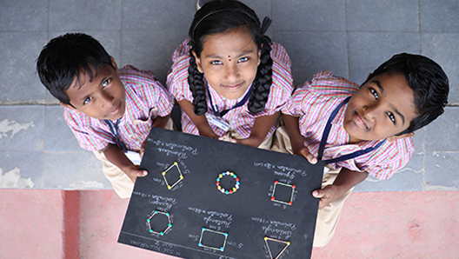

It will cover the age group of 8 to 11 years. The focus would be shifted to play, discovery and activity-based, and interactive classroom learning.

The middle stage, which covers grades 6 to 8, will see a greater focus on subject learning and discussion and more abstract concepts in subjects like science, mathematics, arts, social science, and humanity

The secondary stage years will prepare the students for the final stage of schooling life. The final stage of schooling life for students will be the second stage, in this instead of 2 years, the students will have a complete four years from class 9th to 12th to complete their secondary education.

The existing system of board and entrance exams shall be reformed the need for undertaking coaching classes-students will be able to choose many of the subjects in which they take board exams, 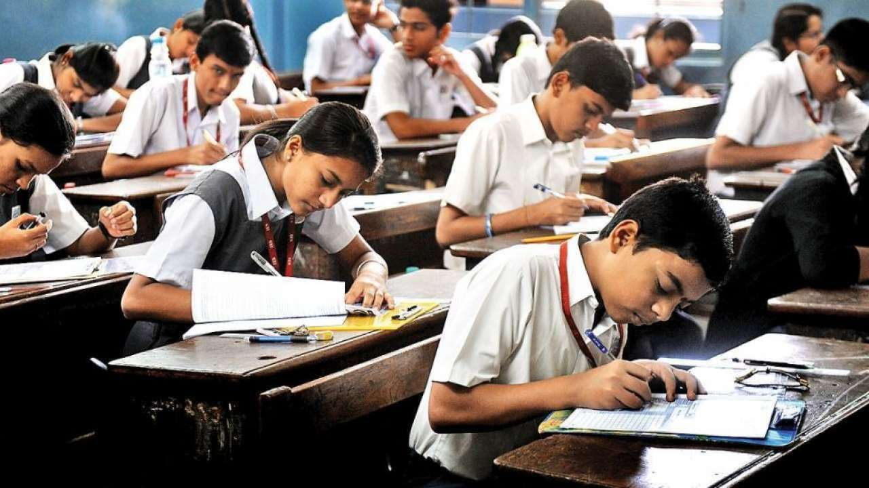

Depending on their individualized interests. Board exams will also be made easier; in the sense that they will test primarily core capacities/competencies rather than months of memorization

A feature of NEP is ensuring universal access at all levels of school education infrastructure support. Tracking the progress of students and their learning levels. Facilitating different modes of learning, including both formal and in-formal education modes.